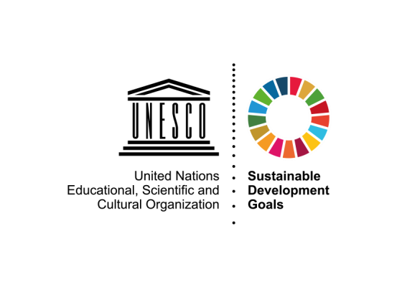

UNESCO International Literacy Prizes 2020
Teaching and learning literacy: The role of educators role and changing pedagogies

Submission form

Part 1. General information of the candidate
1.1 Name of the candidate (Name of the Organization/Individual)*
1.2 Information on the candidate*
Type of candidate | Individual  Governmental  OrganizationInternational  Organization Non-profit  Organization Business  Academia Education - Research Institution National  or local government
Contact person | [Please specify name, title, and department]
Postal Address
Country
Email address
Telephone | [With country code]
Mobile phone number | [With country code]
Website
Description of the candidate | Please provide general information about the candidate
Part 2. Summary statement*
Considering the overall theme of Teaching and learning literacy: The role of educators role and changing pedagogies and the focus areas of the Prizes, why does this project merit a UNESCO Literacy Prize? (maximum 150 words)

Part 3. Information on the project
3.1 Name of the project*
3.2 Objectives of the project*
What are the project’s objectives? (maximum 50 words)

3.3 Abstract*
Summarise the project and its methodology in a maximum of 100 words

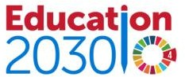

3.4 Start date of the project*
3.5 Estimated end date of the project*
3.6 Target groups*
Which population groups are the main target of your project? Please tick one or more:

Young people (ages 15-24 but could be above and below depending on a definition)
Adults(15+)
Older adults (65+)
Women/ girls Rural adults
Indigenous, marginalized, minority populations Disabled people
Out-of-school children
Specify your own value:
3.7 Geographical coverage of the project*
Please tick and indicate regions, countries, areas or communities covered by your project.

International [Please indicate the countries]
Regional [Please indicate the region covered]
National [Please indicate the name of the country]
Local [Please indicate the names of the community(ies) and/or the area(s) covered] Specify the coverage
3.8 Annual project budget*
3.9 Funding sources
3.10 Number of staff
Please specify the number of staff involved in the project (full time/part time/technical staff/teaching staff/administrative/volunteers)

3.11 website of the project
Part 4. Relevance to the 2020 Theme and the Prizes thematic focus
4.1 What respective Literacy Prize thematic focus your project is addressing?
Please tick one or more:

Development and use of mother-tongue literacy education and training [UNESCO King Sejong Literacy Prize]
Literacy amongst adults in rural areas and out-of-school youth, particularly girls and women [UNESCO Confucius Prize for Literacy]
Both

How your programme is addressing this year thematic focus on Teaching and Learning Literacy:
educators role and changing pedagogies?
Please explain (maximum 50 words)
Part 5. Project delivery
5.1 Teaching
What percentage of the facilitators/teachers have a High School diploma or above? %
What are the average years of teaching experience of the facilitators/teachers of your project? years
How many facilitators and/or teachers of your project work full-time?
How many facilitators and/or teachers of your project are professionals or have another profession besides the project?
How many facilitators and/or teachers of your project have received training and/or support on pedagogy or teaching methodologies?
Does the project provide professional development/training for the facilitators/teachers?
If Yes, please explain (e.g. how many facilitators/ teachers are trained, including the number of days, hours, and type of training) (maximum 50 words)

Please send electronic copies of textbooks and learning materials, if any.
5.2 Project content, materials and language
What kind of activities do learners and teachers carry out?

%
Literacy-related activities
Numeracy-related activities
Work related activities
Others skills

Please add any comments (maximum 50 words)
What textbooks and teaching materials (including ICTs) are used in your project? (maximum 50 words)

Does the project use digital technologies or open distance eLearning material (ODeL) to address access and quality issues or greater diversity of learning resources? If yes, please describe (maximum 50 words)
What areas do the digital technologies used in your project contribute to?

Improving access to learning opportunities/ participation
Enhancing the quality of teaching and learning (e.g. enriched content, making materials available, teaching and learning in local language)
Assessing learning outcomes
Strengthening of administrative systems, governance, administration or programme management (e.g. tracking attendance, financial management, monitoring, etc.)
Enriching literate environments
Data analytics
Other (please describe)
What is the average total number of hours for your courses?
Over how long? (in months)
Total number of hours specifically for literacy learning
Total number of hours for other skills learning
Please indicate the language used in classes (%)
 | Language | %
 | Official language
Mother tongue/national
language
 | Other language
Please describe how the content of your project is aligned with the social; cultural and economic context needs of project participants (maximum 50 words)
5.3 Recognition given to the project
Please list any recognition given to the project if any (e.g. prize, report, academic paper, article, speech)

Please provide web links, if any.

Does the project offer a certificate or a form of recognition, validation and accreditation to the learners who have successfully completed the programme? If yes, please explain how meaningful are they for their further learning and work/profession? (maximum 50 words)
Part 6. Results
6.1 Enrolment, attendance and completion
Number of learners enrolled in the project

Year | Total | Number who are  girls/women
2019
2018
2017

[Please provide numbers of learners enrolled in the project in the recent three years.]

Number of learners who successfully completed the project
 | Total | Number who are  girls/women
2019
2018
2017

[Please provide numbers of learners who successfully completed the project in the last three years.]
6.2 Please describe the level of literacy skills that a learner is expected to achieve at the end of the
course
(Maximum 50 words)
6.3 Does the project measure learners’ literacy skill levels?
If yes, please explain how (including assessment criteria and methods) (maximum 50 words)
6.4 Do you measure the immediate impact of the project on the learners (work, life quality, ect)
If yes, please explain how (maximum 50 words)
Please attach copies of reports
6.5 How do you conduct learning outcomes assessments?
Formative assessment during the learning process
Summative assessment at the end of the training programme
Both formative and summative
Please describe

6.6 Has the project been externally evaluated?
If yes, please attach any relevant document/provide web links, if any
Part 7. Innovative features of the project
What are the most innovative features of the project? (what makes your project different from other programmes). Please explain (maximum 50 words)
Part 8. Partnerships and sustainability
Please explain any partnerships you have built in order to implement the project (maximum 50 words)
What have you done to ensure the sustainability of the project’s results and impacts? (maximum 50 words)
(e.g. follow-up with learners)
Please explain the project’s future plans (maximum 50 words)
(e.g. vision, scaling up, targets, resources, partners, timeframe)
Part 9.Supportive documents*
Please attach supporting documents and materials including:
Project report(s)
Evaluation report(s)
Assessment tools
Evidence of recognition of the project
Guides for teachers/facilitators/instructors
Materials for teaching and learning
Videos/ photos
Any other information
*required field

